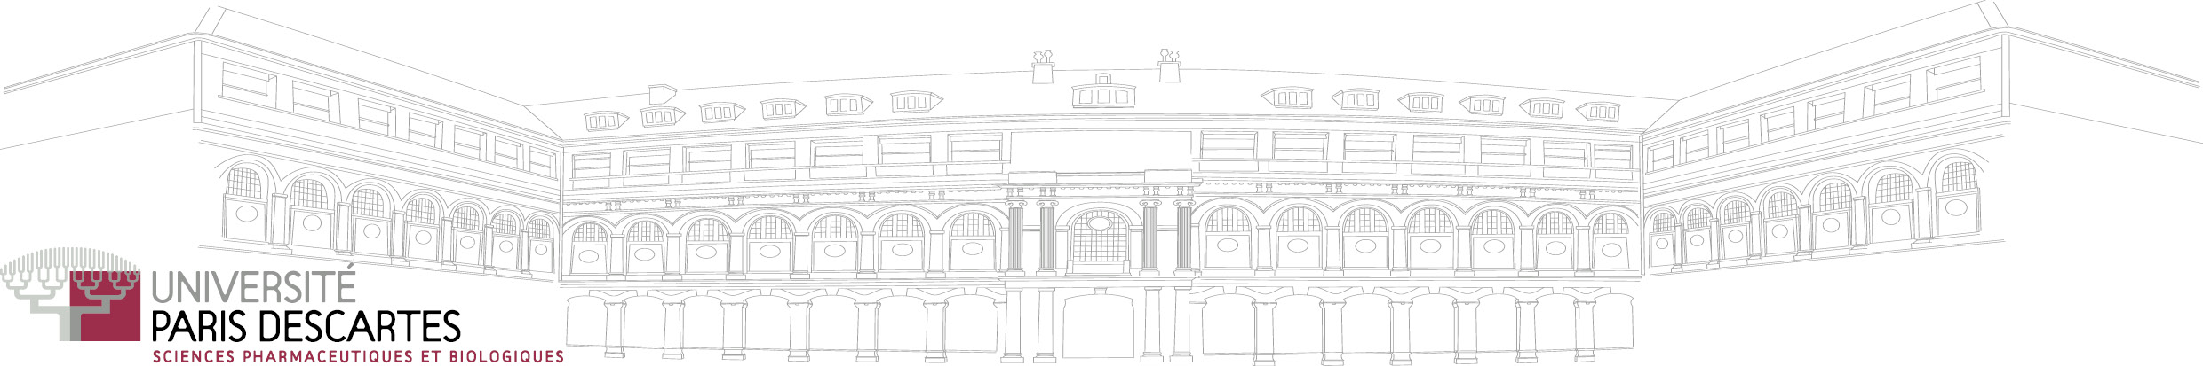
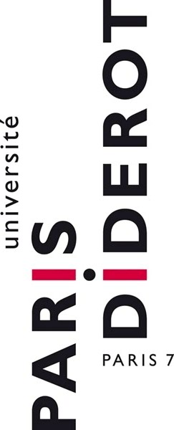



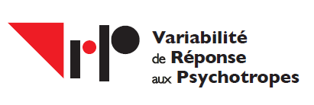
Inserm UMR-S 1144
Directeur : Professeur Jean-Louis Laplanche

Postdoctoral position offer in membrane protein biochemistry

A 2 years postdoctoral position (starting as soon as possible) funded both by the University Paris Descartes and a private pharmaceutical company is available in the team headed by Pr. Xavier Declèves dedicated to the study of the blood-brain barrier (BBB).

Location
INSERM UMRS 1144
Faculty of Pharmacy, University Paris Descartes
Team 3: Blood-brain barrier in Brain Pathophysiology and Therapy
4, Avenue de l’Observatoire 75006 Paris – France

Project outline
The BBB team works on drug transporters, pharmacokinetics, cell signaling and biomarkers in brain diseases. Our objective is to decipher at the molecular level some membrane proteins from the neurovascular unit including the endothelial cells of the BBB.

Profile
Enthusiastic and qualified individuals with a PhD and a strong background and experience in biochemistry and in plasma membrane protein study including protein purification and proteomics are sought. Good communication skills (both written and oral in French and/or English) is required. Salary is commensurate with experience.

Contact
Applying scientists should send a CV, a cover letter summarizing your past experience and references to both:
Prof. Xavier Declèves xavier.decleves@parisdescartes.fr
Prof. Salvatore Cisternino salvatore.cisternino@parisdescartes.fr

